Abstract

In this paper, we propose a method to optimize generation of project groups and panel for review. As an input, the faculty time table and class time table are given. The Free slots of the faculty time table is compared with the project slots of the class timetable to generate project review panels and allocate free faculties into different panels, hence forth the manual work is reduced.
We also propose a method for generating the project groups from the details of a batch. As an input the student details are entered to the system in a predefined excel format. The students are grouped on the basis of their gender and CGPA and an excel file is generated by the system that contains the group details and their login credentials.

Introduction

Creating a review panel and generating project groups for the different batches manually is a painstaking task for the project mentor. The faculty in charge of the project co-ordination needs to assign the students into project groups. In our approach primarily focus on aiding the mentor in creating project groups and their by creating panel for the various phases. The departments of Computer Science and Applications have a few hundreds of students who are doing their academic projects every year. Generating the review schedule for the student group is a time consuming task for the mentor.
For timetabling and scheduling problem, the most commonly used algorithms are Genetic Algorithm[1] and Memetic Algorithm[4]. In our approach we use the concept of gene property from Genetic Algorithm. The timetables are extracted and represented as multi-dimensional arrays. The representation of the arrays used is much similar to the gene representation in Genetic algorithm and the arrays which get altered or modified are much similar to meme[4] of Memetic algorithm.

Literature Review

When generating a review panel from the timetable of teachers and students almost all effective solutions are heuristic in nature, and do not guarantee optimal result. The Problem involves the scheduling of an apt review panel from the timetable of teachers and Students. Review panel generation is a tough problem as there is no known efficient way to locate a solution. Also, the most striking characteristic is that, no best solution to them is known. Hard Constraints are those constraints that cannot be violated while a Review panel is being computed. Soft Constraints are those that are desired to be addressed in the solution as much as possible. For example, though importance is given to a teacher’s schedule, focus is on setting a valid review panel and this can lead to a teacher going free for a time slot or even a teacher being left out from panel generation. In order to find a solution to this problem, a heuristic approach is chosen. This heuristic approach, therein, leads to a set of good solutions (but not necessarily the best solution).
In Genetic Algorithm[1] initially the solutions are encoded into chromosomes, gene is the smallest unit which is represented using six digit. Each digit in the gene represents preference, assignment, course, year, class and credits respectively [1]. The main idea of a genetic algorithm is to explore the neighborhood of the solutions obtained by a genetic algorithm and to navigate the search towards the local optima before passing back to the genetic algorithm containing the process. In our approach the gene concept is applied as dimensions of an array. The faculty ID, day, time slot’s engaged or not is stored in the multi-dimensional array.
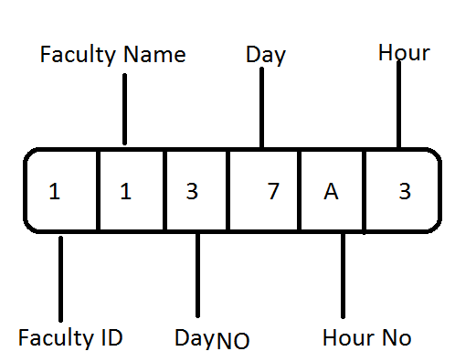

Fig 1.Gene Representation

In Memetic algorithm (MA)[4] a meta-heuristic approach is adopted, the word meme can be considered as a gene of Genetic Algorithm. In most of the MAs a search strategy which populates the desired agents co-operates and competes. MAs are an important optimization approach which focuses on technical and formal features without losing any research and practical aspects. A meme is the simplest form of information that can be transmitted between individuals, unlike a gene here the information can be processed and enhanced or altered by the communicating entities.
A cryptographic hash function allows to verify that some input data maps to a given hash value, but if the input data is unknown; it is deliberately difficult to reconstruct it (or equivalent alternatives) by knowing the stored hash value. This is used for assuring integrity of transmitted data, and is the building block for Hash based message authentication code’s (HMAC) which provide message authentication.
The cryptographic function, Message Digest algorithm5 (MD5) is a 128 bit hash value, use widely in security applications. MD5 is a hexadecimal hash expressed in 32 digit, it’s an extension of MD4 algorithm, MD5 is slightly a slower version of MD4 .
The input message is broken up into chunks of 512-bit blocks (sixteen 32-bit words); the message is padded so that its length is divisible by 512. The padding works as follows: first a single bit, 1, is appended to the end of the message. This is followed by as many zeros as are required to bring the length of the message up to 64 bits fewer than a multiple of 512. The remaining bits are filled up with 64 bits representing the length of the original message.
The following demonstrates a 43-byte ASCII input and the corresponding MD5 hash.

MD5("The students are drowning over the project") =
9e107d9d372bb6826bd81d3542a419d6

Methodology
Automatic Group generation
Creation of project groups from the student list is usually a time consuming manual work for a project mentor. This system automates this. As an input an excel file with the details of the student name, roll no, gender, CGPA as shown in fig 2 is input.
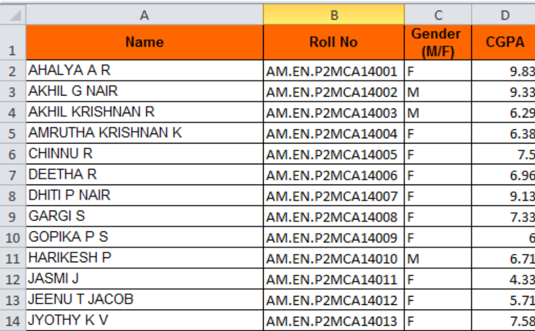
The excel file input is sorted based on gender and is extracted to a two dimensional string array using the Apache POI package [3]. Poor Obfuscation Implementation (POI)[5] is an API that access Microsoft Office formats, developed by Apache Software Foundation. Then these arrays are sorted on the basis of the students CGPA. Each group is assigned with a unique group number, which is a combination of the batch semester and year. Example: “Group3_mca_s5_2015”. If the students in a batch are not divided equally then a single group is formed with the leftover students. The groups are created in such a way that each group will contain students with high and low CGPA. Once the groups are generated, each group is provided with a group number. Next a login table is created for this batch and all this details are written to that table. The initial password for each group is the group name itself and will be asked to replace on initial login, the passwords to the accounts are protected using an MD5 hashing algorithm [2]. The advantage of using an MD5 algorithm is that the passwords stored in the database are hash codes of the original password and hence even if someone gets access to the database and get the passwords they will get only the hash codes and hence if they try to login with the hash code it will be hashed again.

Fig 2. Students database
Generation of Review Schedule
The tool is input with the faculty and student timetables which is already in a prescribed format (Fig 3 and Fig4). In case of the faculty’s timetable, it should not have any merged cells other than the name of the faculty and may or may not have Saturday as a working day. The system will work with different number of hours for a day as the tool will detect the last cell in a row. The first column contains the name of the faculty and the days, the first and second rows contain the times and the number of each working hour. So the actual class hours will start from the third row’s second column. Once this has been identified the next objective was to extract the contents (whether a cell is occupied or not) from an excel to a two dimensional Boolean array which was the same size as that of the excel file, this had been achieved by using Apache POI package[3]. The number of rows in the Boolean array is calculated as the no of last row in the excel sheet plus one and the number of columns are calculated as the number of cells in the first row. If a cell had any value then “true” is stored in the corresponding location of the Boolean array otherwise a “false” is stored, thus the entire excel file is mapped to a Two dimensional Boolean array. The names of the faculties are extracted to a different single dimensional string array. The number of faculties in the excel is computed as the last row number on the excel file divided by 8(if Friday is the last working day) or 9(if Saturday is the last working day) plus one. The next challenge faced was to find the cells which contained the name of the faculties, as the excel contained different cells with string values, which could only be done by identifying the location (cell number) where the name would appear as the timetable needs to stick to the specific format. The first cell in the excel will have the name of the faculty and the next cell that will have the faculty name can be calculated as a product of last working day of the week (8 in case of Friday and 9 in case of Saturday) and no of cells in a row.
Once the extraction of faculty timetable is over the system starts to extract the timetable of the batch. Unlike the timetable of the faculty, which contains the schedule for all the staffs in the department, the student’s timetable contains only the timetable of a particular batch in a file. Here the timetable should stick to the specified format and the system can handle cases where the last working day is Friday or Saturday and can also adjust with different hours for a day. This is possible as the tool takes the last row number and the last cell in a row to calculate the number of hours and the days in the timetable. The content in the excel file is extracted to two dimensional Boolean array. The array is created in the same way as the array for the faculty timetable with the help of Apache poi packages. The project code number of concurrent review panels and the time period for each panel is entered by the user. The timetable of the batch is scanned to find the cells that have the same project code and the corresponding cell in the Boolean matrix is marked with a true else marked with a false. On successful extraction of the student timetable the mapping of the faculty timetable from two dimensional Boolean array to a three dimensional Boolean array is started with one dimension for each faculty in the department the other dimension for the days and 9 he last dimension for the number of working hours. In this mapping from the 2 dimension array to the 3 dimension array only the class hours are mapped such that the students project hours are an exact match with the teachers free hours. These details are stored to a temporary database for further processing. Once both the extractions are complete the days for which the reviews should be scheduled is provided to the system. Only the details of those days are written to the database and hence the database contains the list of lecturers and their free hours and the project hours of the students.
From the database the number of days for which the panel has to be generated will be extracted along with the number of hours in each day. Then the teacher’s names are extracted from the temporary database who are free in a particular hour on a particular day. Then panels are generated by selecting 2 faculties who are free at the same time on the same day and assigned with a panel number. The number of student groups is compared with the number of panels to decide if it is possible to schedule reviews for all. An option is provided to set the maximum no of concurrent panels. if the review for all the students cannot be scheduled then the system notifies the user about the same and asks the user to enter a higher limit for the number of concurrent panels or to provide more days to schedule the review.
This part includes any specific methodology or in general how you plan to approach the problem. Reference may come here also, but your intention will take a higher place than others. Any required mathematical equation, or any other inference which will substantiate your methodology can be included here with appropriate reference. You can be bit elaborate on this part and the next part.
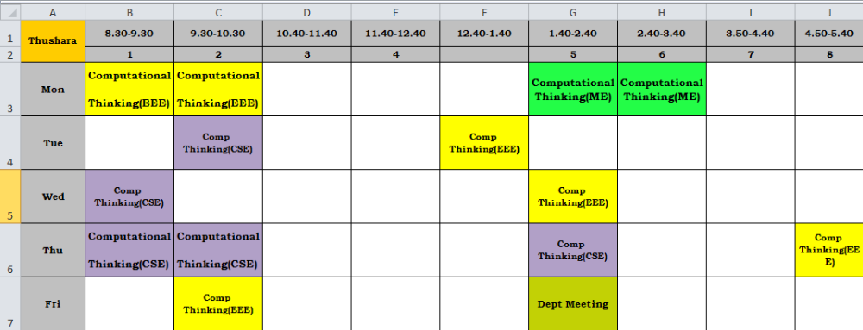

Fig 3. Teachers Timetable
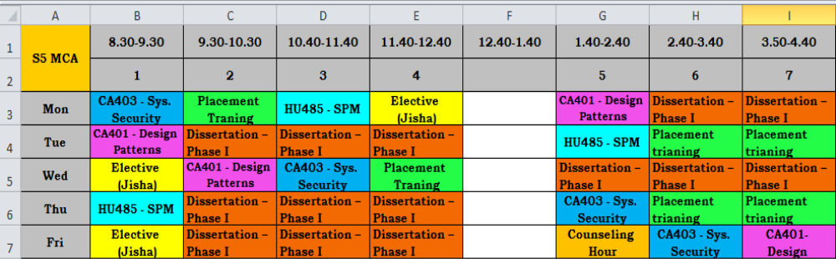

Fig 4: Students Timetable

Results and Analysis
With the help of this system the project mentors work has become easier as the project group generation can be done in a few minutes just by providing the system with the list of the students in a batch in a prescribed manner. The tool will output an excel file which contains the details of group members and their initial login credentials as shown in fig 5.
The tool also provides an option to generate the review panel in such a way that the panels match with the project hour of the batch for which the panel is being generated. Sample of the generated panel is as shown in fig 6. The tool lets the mentor to control the number of concurrent panels and lets the mentor know if it is possible to schedule the review for all the groups with the generated no of panels.

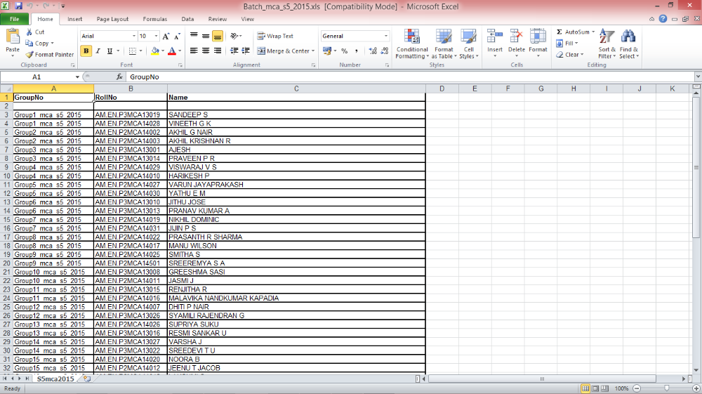

Fig 5. Generated Group

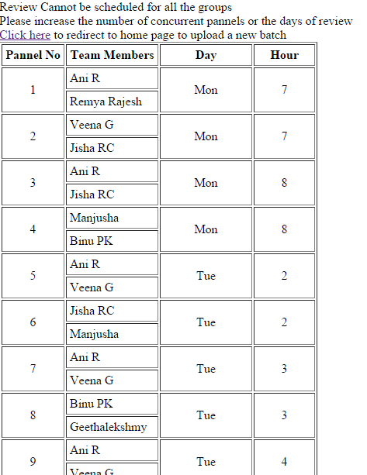

Fig 6. Generated panel list

Conclusion & Future Work
The optimized Method for the Generation of Project Groups and Panels from the Time Table has been developed. The result is satisfactory when it is applied to the real case of timetabling and scheduling. Based on the different experiments conducted, the review panel generated by the system is much faster and error free than the review panels generated manually. The tool is able to generate the review panel in a matter of few minutes when compared to creating the panel manually

The future scope for the system can be further enhanced to become a pool of reference for the Students and Faculty in selecting a project or a thrust area. Selecting a project and guide is one of the difficult tasks faced by a student, with the aid of this system, a student could easily understand the different thrust areas in which more research work occurs and the faculties associated with each thrust area. This tool would give a detailed analytic report on which thrust area more research occurs. It could be done with the help of graphical representations like bar charts or pie charts. Tool could be further enhanced to work as a grading system for the project by providing the students to upload the project related documents and the associated marks for each review.

References
[1] Dedy Suryadi and Rizaldy Pilipus, Genetic Algorithm for University Timetable Planning in FTI, Department of Industrial Engineering , Parahyangan Catholic University, Bandung 40141, Indonesia
[2] Edmund K. Burke, James P. Newall, Rupert F. Weare , A Memetic Algorithm for University Exam Timetabling, Department of Computer Science, University of Nottingham
University Park, Nottingham NG7 2RD, UK.
[3] Recent research directions in automated timetabling
Automated Scheduling, Optimisation and Planning (ASAP) Research Group, School of Computer Science and Information Edmund Kieran Burke, Sanja Petrovic
Technology, University of Nottingham, Jubilee Campus, Nottingham NG8 1BB, UK
[4]Alpay Alkan ,Ender Özcan Yeditepe , Memetic Algorithms for Timetabling
University Department of Computer Engineering,
34755 Kayisdagi - Istanbul/Turkey
[5] Peter Cowling, Graham Kendall, Eric Soubeiga, Hyperheuristics: A Tool for Rapid Prototyping in Scheduling and Optimisation, Automated Scheduling, optimisAtion and Planning (ASAP) Research Group, School of Computer Science and Information Technology (CSIT), The University of Nottingham, Jubilee Campus, Wollaton Road, Nottingham NG8 1BB, England,
United Kingdom
[6] TimetablesJonas MOCKUS, Lina PUPEIKIENE˙, On Multi-Start Algorithms for Optimization of High School Vilnius University, Institute of Mathematics and Informatics
Akademijos 4, LT-08663 Vilnius, Lithuania
[7] Ihab Sbeity, Mohamed Dbouk and Habib Kobeissi , COMBINING THE ANALYTICAL HIERARCHY PROCESS AND THE GENETIC ALGORITHM TO SOLVE THE TIMETABLE PROBLEM
, Department of Computer Sciences, Faculty of Sciences, Section I, Lebanese University, LEBANON
[8]Pablo Moscato, University of Newcastle, Carlos Cotta University of Malaga, A Gentle Introduction to Memetic Algorithms
[9]Errata Exist Network Working Group R. Rivest ,Request for Comments: 1321 MIT Laboratory for Computer Science and RSA Data Security, Inc. April 1992
[10]Design and implementation of massive MYSQL data intelligent export system to excel by using Apache –POI libraries

